Yannick Even

Global Analytics Business Partner
Swiss Re
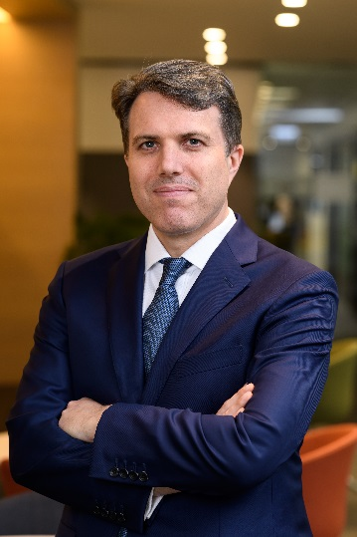
Yannick is a member of the Advanced Analytics center of expertise management coordinating the delivery of the data & analytics strategy for the Swiss Re Group and in particular across the APAC region, where he oversees the delivery of Responsible AI based solutions, research, partnerships and thought leadership.
Yannick joined Swiss Re in December 2016 as the first Insurtech Solutions Head. Prior to that he was member of the Digital and Innovation practice of KPMG China Advisory for 4+ years.
Yannick has more than 2 decades experience managing data and delivering analytics and tech-enabled solutions worldwide. He has been based in Hong Kong for 12+ years before relocating to Zurich in September 2022.
He is an alumnus of the Indian School of Business and Polytech Montpellier France, a recognized Insurtech and Responsible AI influencer with 11k followers and also Board advisor of The Care Voice (a global Healhtech) since September 2022.

